**Monitoring Application**

**Note:**

**In The Section I using Portainer**

**Portainer: Powerful container management** Deploy, configure, troubleshoot, and secure containers in minutes on Kubernetes, Docker, Swarm and Nomad in any data center, cloud, network edge or IIOT device.

1. **First install portainer In Docker , create account and login.**

1. **Now get start using and check container , images are using in local machine.A screenshot of a computer

   Description automatically generatedA screenshot of a computer

   Description automatically generated**
2. **Create stack to connect multiple containers in my status and create (node-exporter , Prometheus and Grafana) in the same Network(test monitoring).**

**Stack allows for multiple services, which are containers distributed across a swarm, to be deployed and grouped logically.**

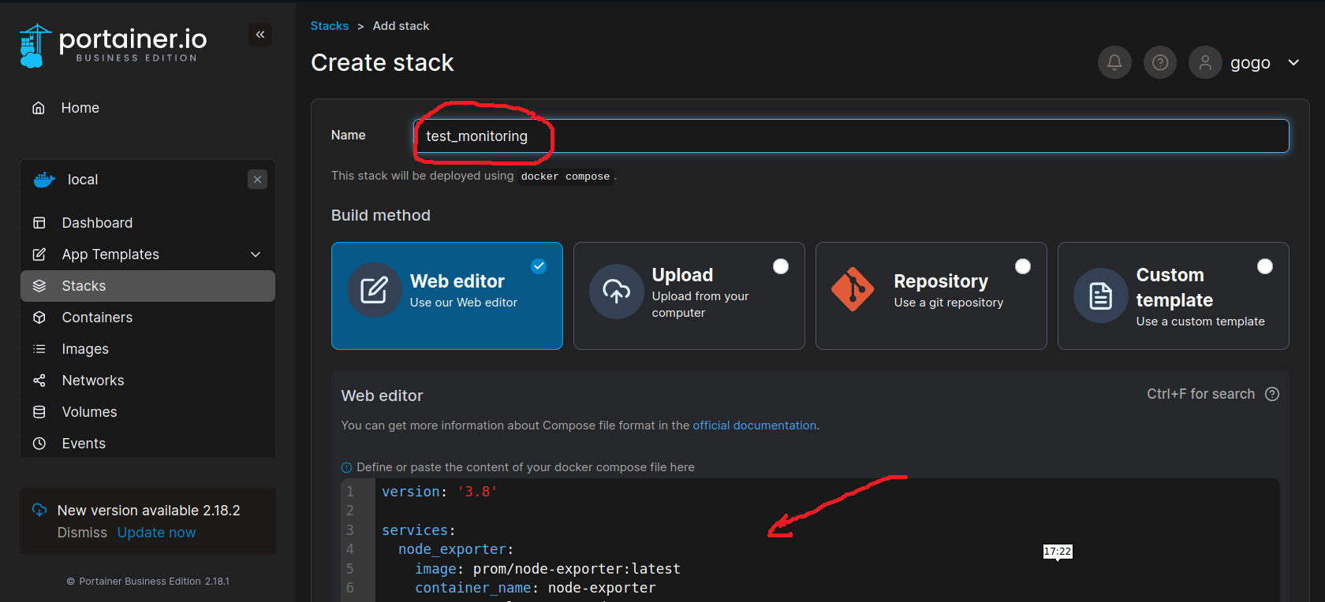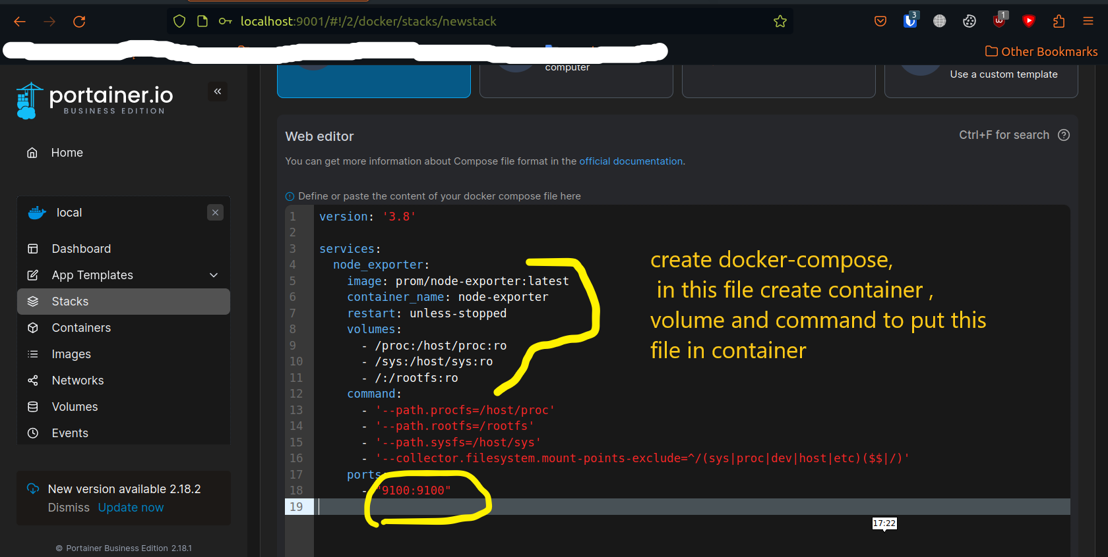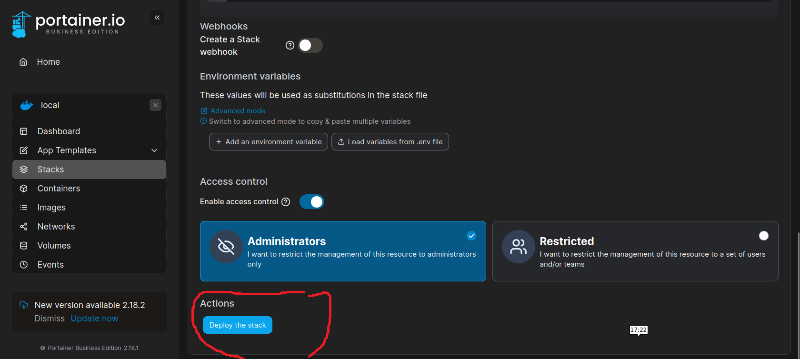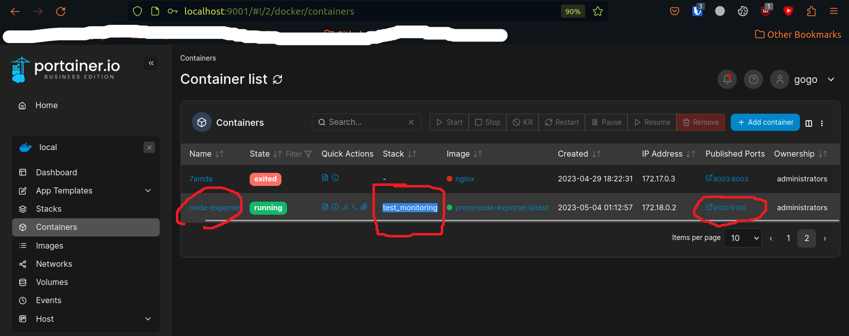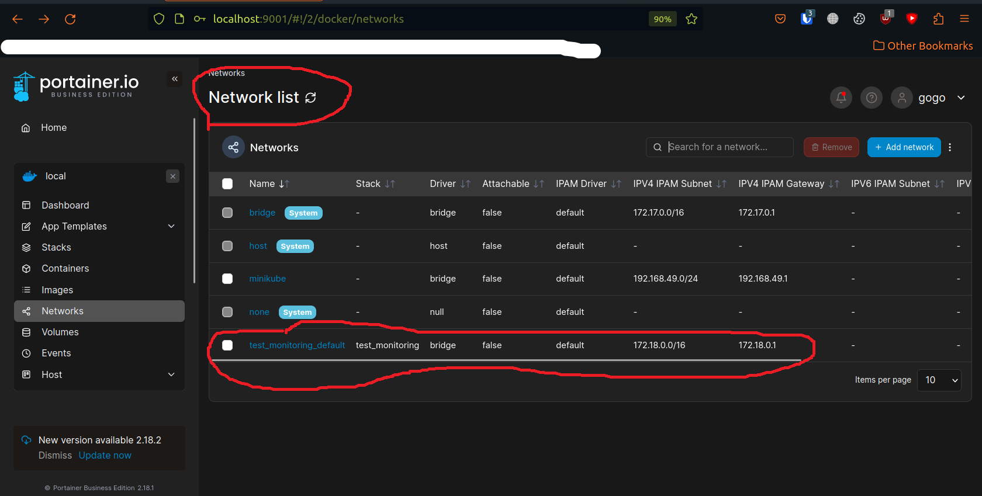

1. **Now Run Prometheus into Docker , set persistent volume and Attach container to Network which I created (test monitoring)**

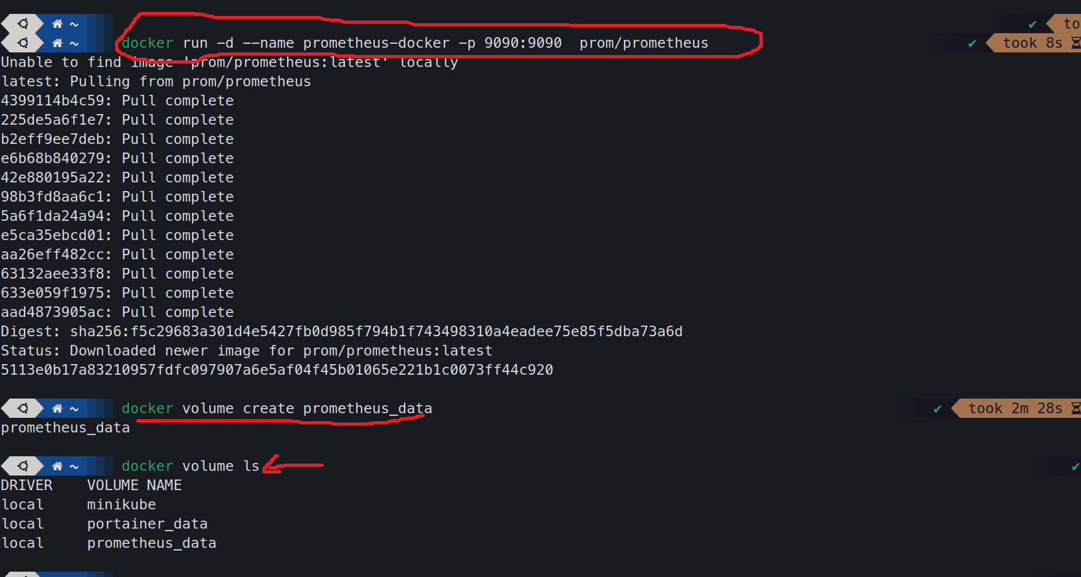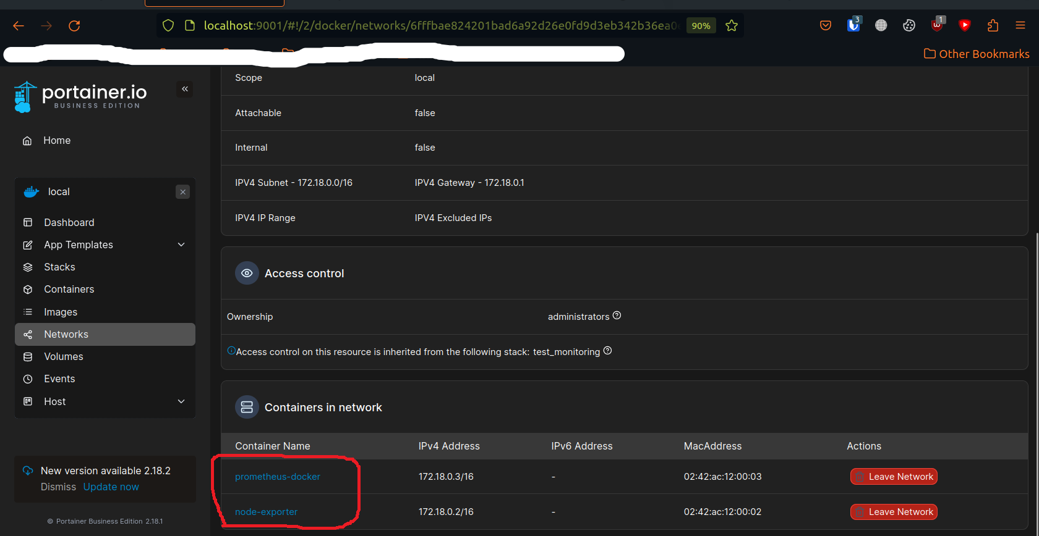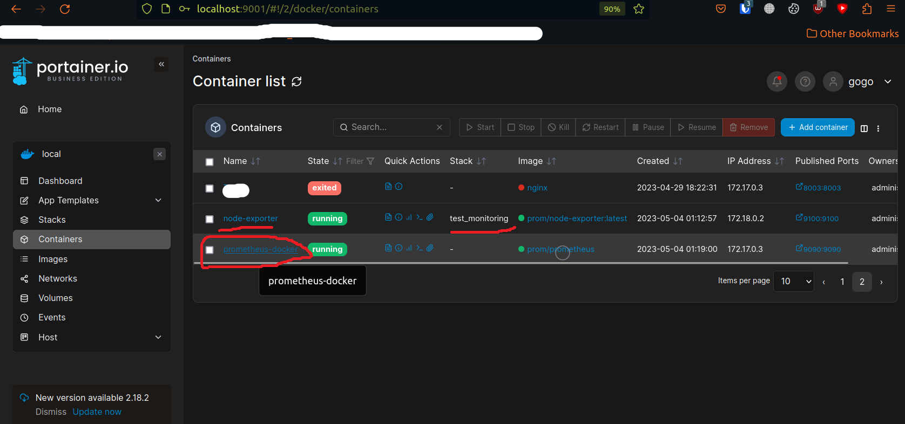

**(Optional) If you want to access bash of container**

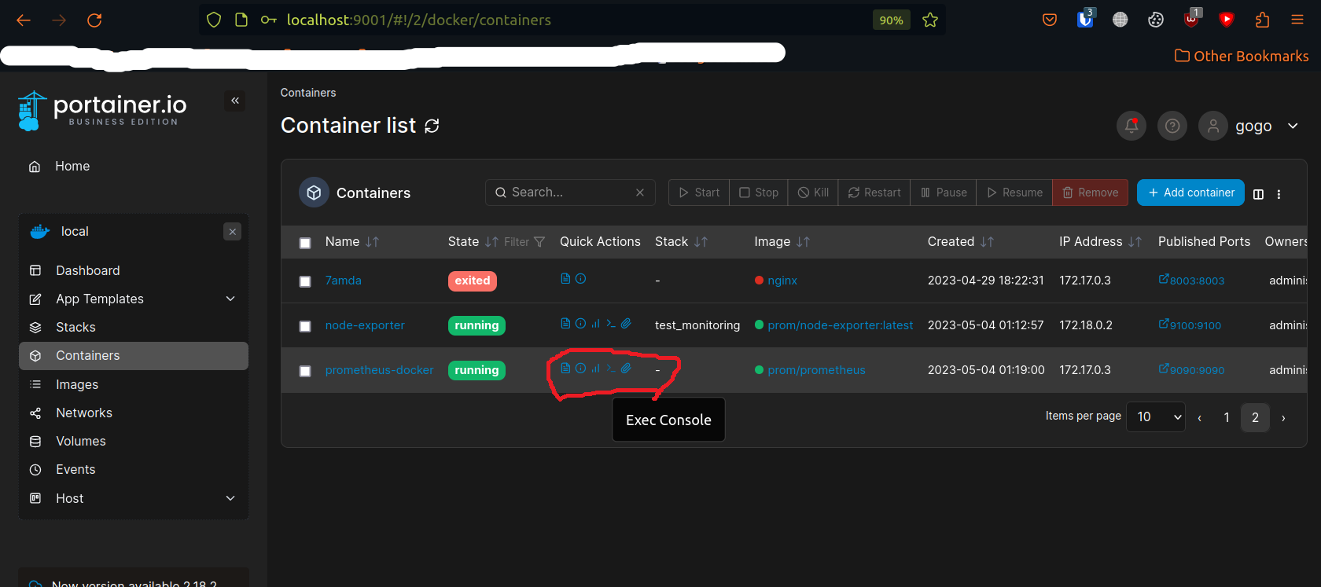

**5- Now Run and test Prometheus using port 9090**

**6- Run Grafana into Docker and set persistent volume and Attach container to Network (test monitoring)**

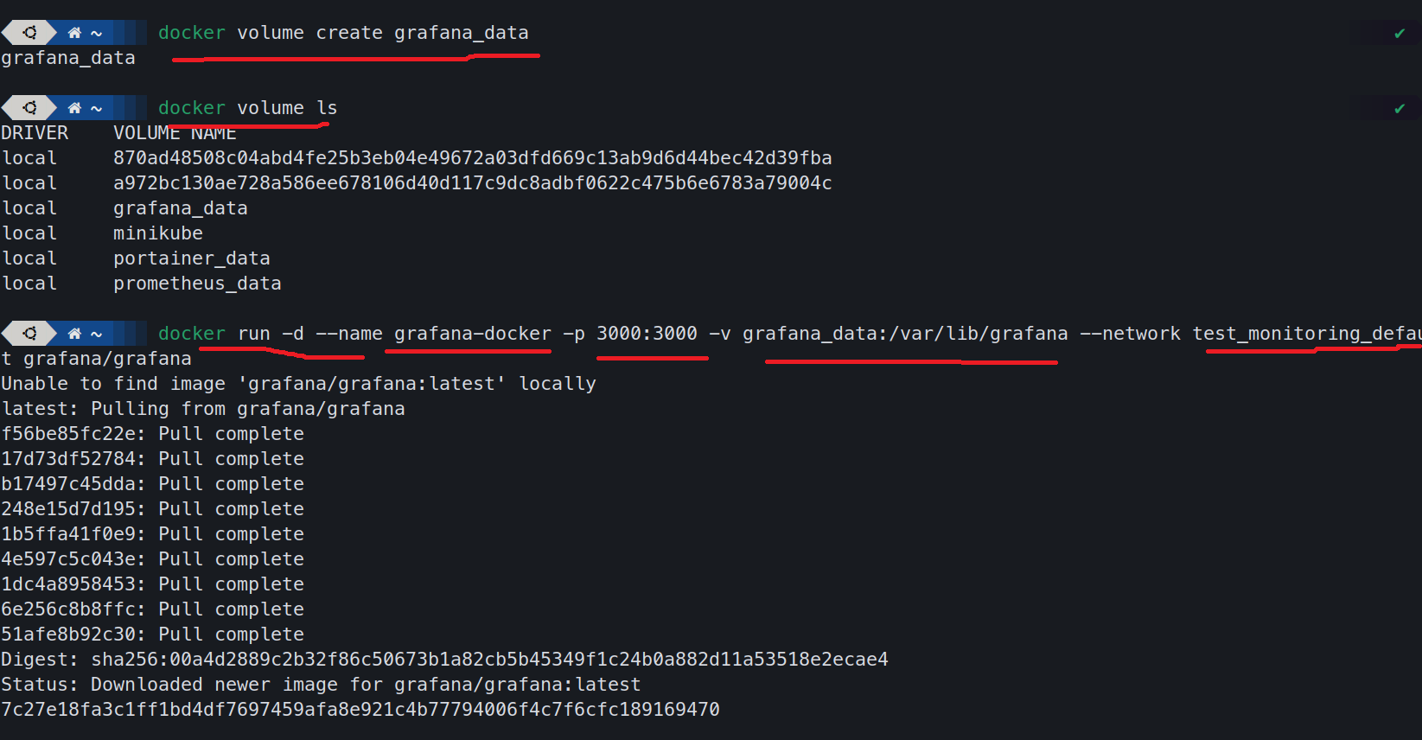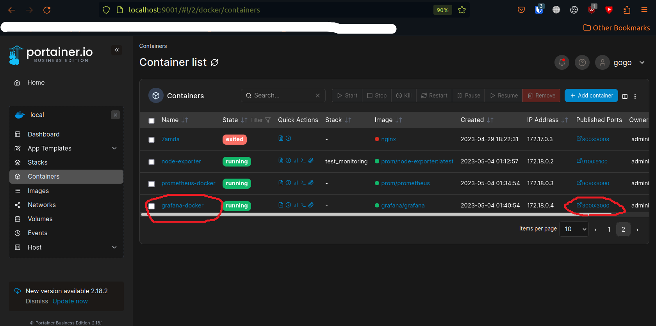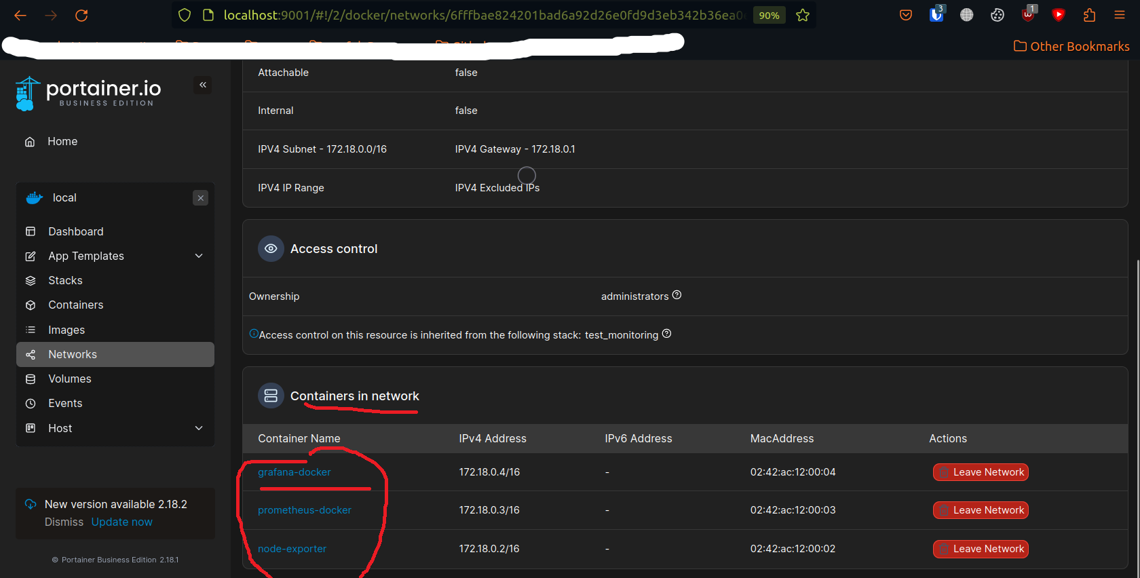

1. Finally Connect Grafana to pull data from Prometheus (http://localhost:3000)

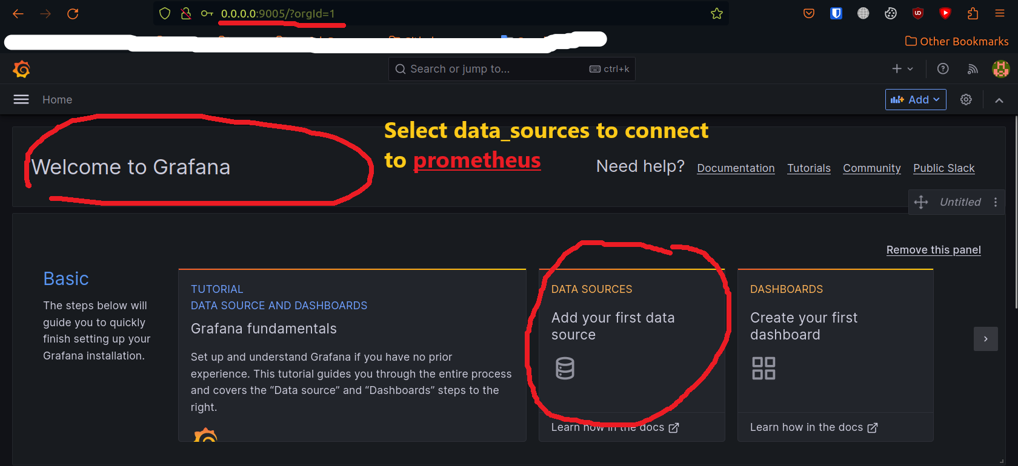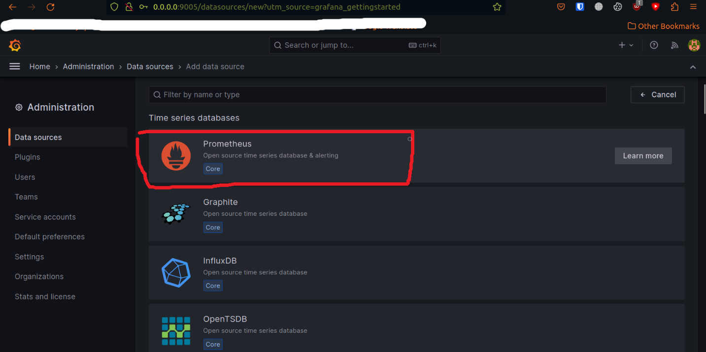

Using Ip machine and port of Prometheus (http://IP:9090)